NUnit and Moq

Objective:
Develop a unit testing project using NUnit Framework to validate the functionality of the Calculator class. The project demonstrates the use of TestFixture, SetUp, TearDown, TestCase, and Assert.That() for automated unit testing.
Project Structure:
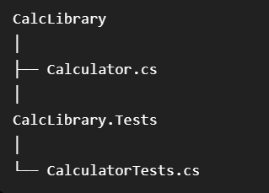
Implementation:
Calculator.cs:
namespace calcTests
{
public class Calculator
{
public int Add(int a, int b)
{
return a + b;
}
}
}
CalculatorTests.cs:
using NUnit.Framework;
namespace calcTests
{
[TestFixture]
public class CalculatorTests
{
private Calculator calculator;

[SetUp]
public void Setup()
{
calculator = new Calculator();
}

[TearDown]
public void Cleanup()
{
calculator = null;
}

[Test]
public void AddTest()
{
Assert.That(calculator.Add(5, 10), Is.EqualTo(15));
}

[TestCase(2, 3, 5)]
[TestCase(10, 20, 30)]
[TestCase(5, 5, 10)]
public void AddTestCases(int a, int b, int expected)
{
Assert.That(calculator.Add(a, b), Is.EqualTo(expected));
}
}
}

OUTPUT:
